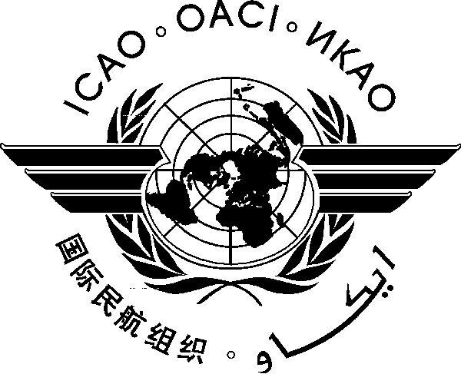International Civil Aviation Organization

Third Meeting of the APRAST – Accident Investigation Ad hoc Working Group
(APRAST-AIG AWG/1)

(Bangkok, Thailand, 6-8 June 2012)

Agenda Item X: | Xx

TITLE

(Presented by State/Organization)

SUMMARY
Xx.

- IntroductioN
  - Xxx.
- Discussion
  - Xxx.
- Action by the Meeting
  - The meeting is invited to:
- Xx;
- Xx; and
- Xx

— — — — — — — —

— END —

